**Lanzhou University (1909- )**

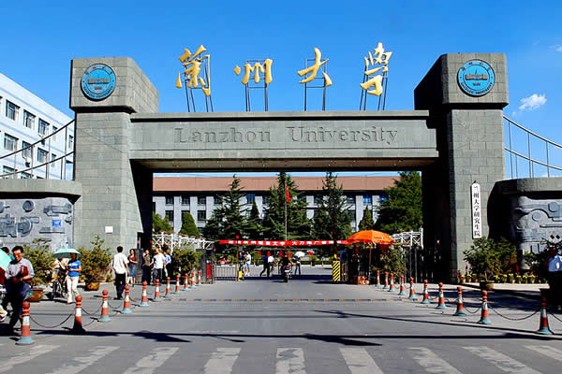

**Main gate of the main campus**

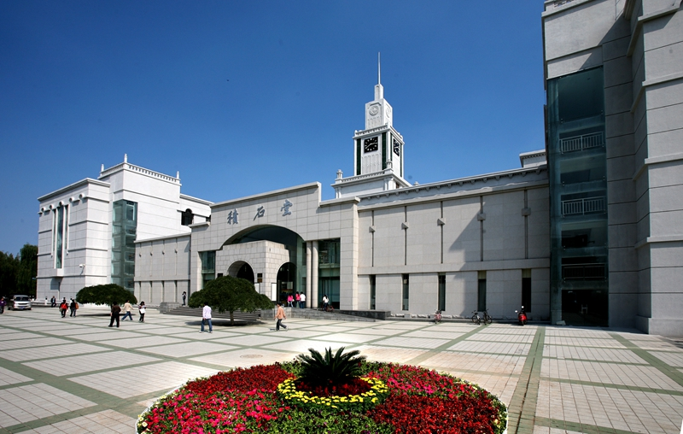

**The library in the main campus**

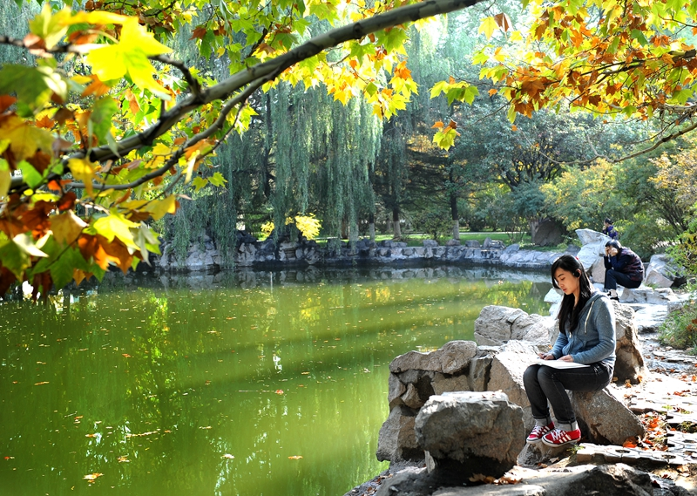

**Yuxiu Lake**

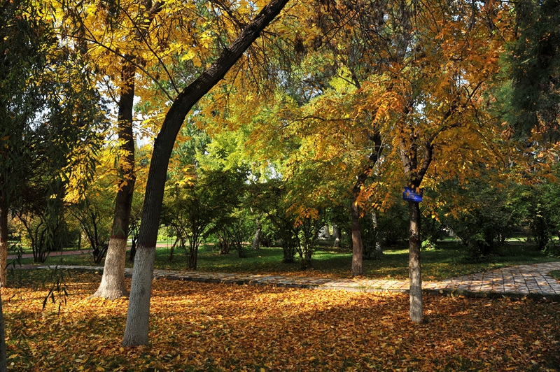

**Beautiful campus**

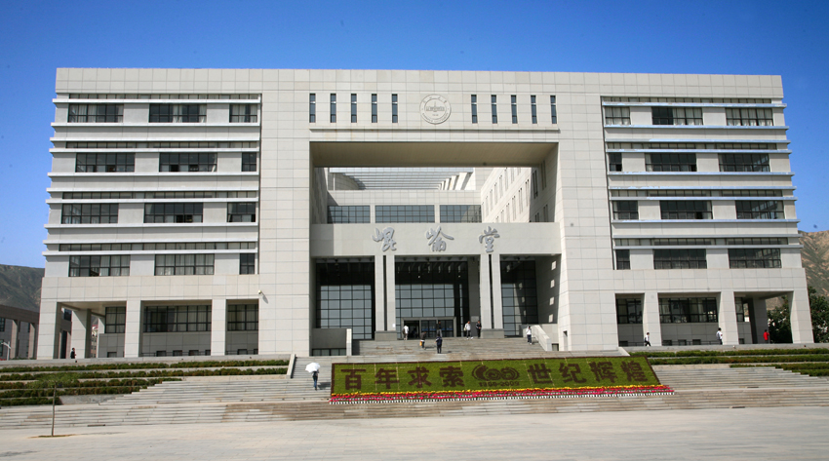

**The library in Yuzhong campus**

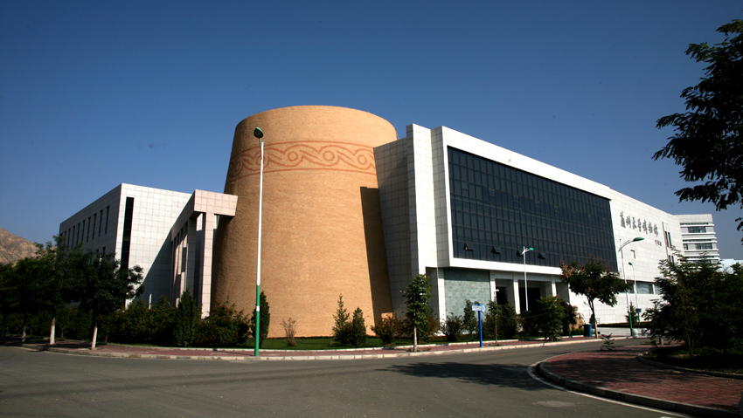

**The museum**

**The charming city - Lanzhou**

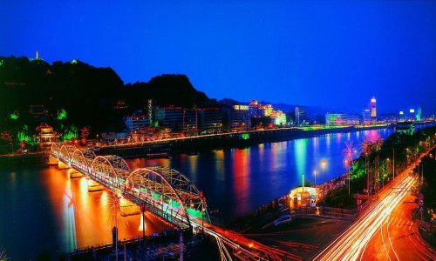

**Night view of Lanzhou city**

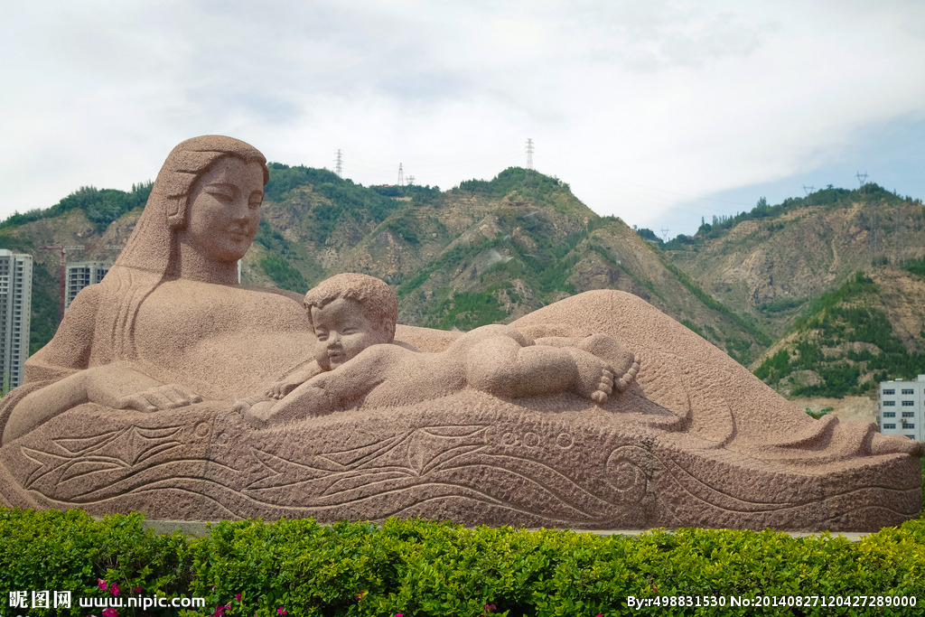

**The Sculpture of the Yellow River Mother**

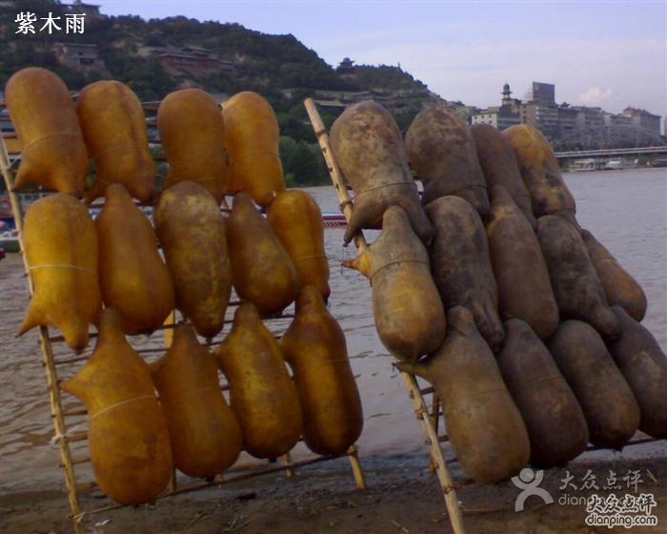

**The old transport tool in the Yellow River - Sheepskin Rafts**

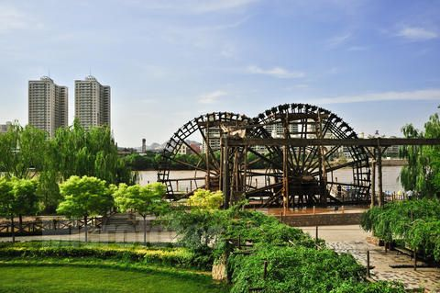

**The ancient irrigation system - Waterwheels**

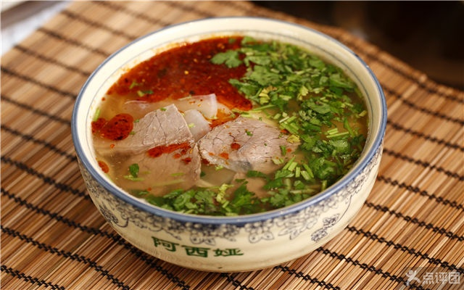

**Lanzhou beef noodles – a business card for Lanzhou City**

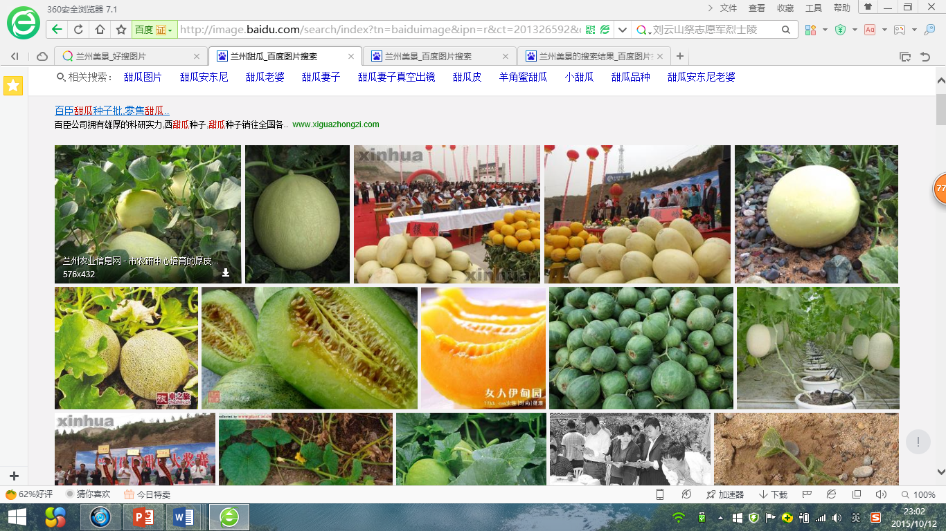

**Large varieties of sweet fruits**